AGENDA – JANUARY COUNCIL MEETING Monday 13th JANUARY 2020
To the Chairman and Councillors of the Grosmont Fawr Community Council

You are summoned to attend the next meeting of the Grosmont Fawr Community Council, which will be held at the GROSMONT TOWN HALL, on MONDAY 13th January at 7:30pm. The business to be transacted is as set out in the agenda below.
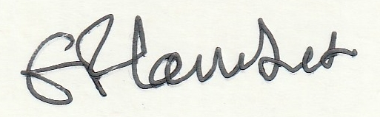
Frances Lambert - Clerk of the Council and Responsible Financial Officer

- To accept apologies for absence:
- To disclose personal and pecuniary interests in items of business listed below:
- Public Forum - (The meeting will be suspended to permit the Public Forum – 10 minutes only and
each participant limited to 2 minutes. The meeting will then be re-opened.)
- To consider matters relating to the Grosmont (Rural) Futures Project including play area at the Castle.
- To approve as a correct record the Minutes of previous meetings held.
- To consider matters arising from the minutes:
- To receive items of correspondence:
- To consider matters relating to Highways / Rural Roads:
- To consider matters relating to planning – as listed below:
DM/2019/01951 This application seeks permission to make alterations and improvements to convert five redundant farm buildings that form a part of the former Old Court Farm complex, into residential accommodation associated with the main house, and follows a Pre-App MC /2016/enq/00481, made in July 2016. The proposal will also facilitate the provision of courtyard and garden areas for the benefit of the main house. Together these changes will move the general setting of Old Court and its associated complex from that of a working farmstead; one now redundant, to that more befitting an important Medieval Court House. Old Court Farm Old Court Road Llangattock Lingoed Abergavenny Monmouthshire NP7 8NP

- To consider matters relating to Grosmont Town Hall:

- To consider matters relating to Grosmont Events.

- To agree expenditure and other accounts matters.

- To receive and consider any other business: (Items for noting only – matters requiring further consideration will be listed for a future council meeting).

- Closed session of Council to consider matters arising from the Internal audit and staffing matters.

Date of next council meeting MONDAY 9th MARCH 2020 at 7:30pm.

