AGENDA – MARCH COUNCIL MEETING Monday 9th March 2020
To the Chairman and Councillors of the Grosmont Fawr Community Council

You are summoned to attend the next meeting of the Grosmont Fawr Community Council, which will be held at the GROSMONT TOWN HALL, on MONDAY 9th March at 7:30pm. The business to be transacted is as set out in the agenda below.
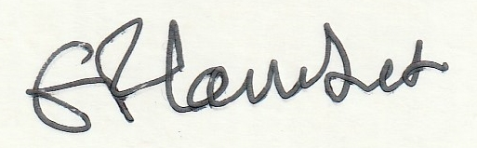
Frances Lambert - Clerk of the Council and Responsible Financial Officer

- To accept apologies for absence:
- To disclose personal and pecuniary interests in items of business listed below:
- Public Forum - (The meeting will be suspended to permit the Public Forum – 10 minutes only and
each participant limited to 2 minutes. The meeting will then be re-opened.)
- To consider matters relating to the Grosmont (Rural) Futures Project including play area at the Castle.
- To approve as a correct record the Minutes of previous meetings held.
- To consider matters arising from the minutes:
- To receive items of correspondence:
- To consider matters relating to Highways / Rural Roads:
- To consider matters relating to planning – as listed below:
- DM/2019/01759 25/02/20
Planning permission for Additional vehicular parking onto the B4347. Cupids View, B4347, Grosmont Bridge to Whitehouse farm, Grosmont, Monmouthshire, NP7 8ES.

- DM/2019/02046 17 January 2020
Description Of Proposal: Householder Replace front entrance conservatory. Existing timber structure to be removed and replaced in white UPVC. Lleoliad/Location: 1 The Malt House A465 Great Goytre Farm To St Ciwas Church Grosmont Abergavenny Monmouthshire NP7 8HE

- To consider matters relating to Grosmont Town Hall:

- To consider matters relating to Grosmont Events.

- To agree expenditure and other accounts matters.

- To receive and consider any other business: (Items for noting only – matters requiring further consideration will be listed for a future council meeting).

- Closed session of Council to consider matters arising from the Internal audit and staffing matters.

Date of next council meeting and AGM on MONDAY 11th MAY 2020 at 7:30pm.

