AGENDA – NOVEMBER COUNCIL MEETING Monday 11th NOVEMBER 2019
To the Chairman and Councillors of the Grosmont Fawr Community Council

You are summoned to attend the next meeting of the Grosmont Fawr Community Council, which will be held at the GROSMONT TOWN HALL, on MONDAY at 7:30pm. The business to be transacted is as set out in the agenda below.
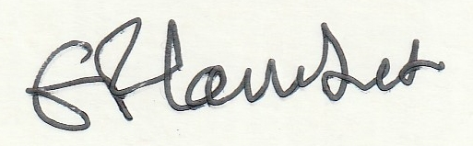
Frances Lambert - Clerk of the Council and Responsible Financial Officer

- To accept apologies for absence:

- To disclose personal and pecuniary interests in items of business listed below:

- Public Forum - (The meeting will be suspended to permit the Public Forum – 10 minutes only and
each participant limited to 2 minutes. The meeting will then be re-opened.)

- A short presentation from Marc Edwards of Broadway partners concerning better broadband provision for the area.

- To consider matters relating to the Rural Futures Project including play area at the Castle.

- To approve as a correct record the Minutes of previous meetings held – 13th May 2019.

- To consider matters arising from the minutes:

- To receive items of correspondence:

- To consider matters relating to Highways / Rural Roads:

- To consider matters relating to planning – as listed below:
For Courtesy not consultation:
Room to store feed for livestock as well as livestock item sales.
Location: Graig Farm, Hillcrest To Greig Farm House, Cross Ash, Monmouthshire, NP7 8PH .

- To consider matters relating to Grosmont Town Hall:

- To consider matters relating to Grosmont Events.

- To agree expenditure and other accounts matters.

- To receive and consider any other business: (Items for noting only – matters requiring further consideration will be listed for a future council meeting).

- Closed session of Council to consider matters arising from the Internal audit.

Date of next council meeting MONDAY 12 th January 2020 at 7:30pm.

