AGENDA – for the 9th SEPTEMBER 2019 COUNCIL MEETING
To the Chairman and Councillors of the Grosmont Fawr Community Council:
You are summoned to attend the next meeting of the Grosmont Fawr Community Council, which will be held at the GROSMONT TOWN HALL, on MONDAY 9^{h} of September 2019 at 7:30pm. The business to be transacted is as set out in the agenda below.
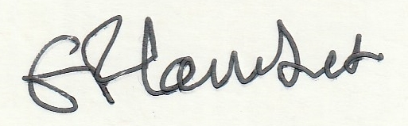
Frances Lambert - Clerk of the Council and Responsible Financial Officer

- To accept apologies for absence:

- To disclose personal and pecuniary interests in items of business listed below:

- Public Forum - (The meeting will be suspended to permit the Public Forum – 10 minutes only and each participant limited to 2 minutes. The meeting will then be re-opened.)

- To consider matter relating to Grosmont events.

- To consider matters relating to the Rural Futures Project:

- To approve as a correct record the Minutes of previous meeting held – 8th July 2019.

- To consider matters arising from the minutes.

- To receive items of correspondence.

- To consider matters relating to Highways / Rural Roads.

- To consider matters relating to planning – as listed below:
  - DM/2019/01029 Alterations and improvements to three redundant buildings which form a part of the wider Old Court complex, which will be referred to in the application as Cart Shed (CS), Large Modern Barn (LMB) and Block House (BH). CS upgraded and converted into a gym, LMB reconfigured and upgraded to provide Sui Generis/B1 uses, and BH replaced with a new building to provide garaging, a plant and storage room, and staff accommodation. Location: Old Court Farm ,Old Court Road,Llangattock Lingoed,Abergavenny,Monmouthshire,NP7 8NP
  - DM/2019/01328.Discharge of conditions 4 (landscaping) and 6 (means of enclosure) from planning consent.
  - DM/2019/01232. Retrospective change of use of land for the siting and use of up to 18 caravans for holiday accommodation use throughout the year. Land adjacent Church Cottage, Church Lane, Llanvetherine, Monmouthshire.

- To consider matters relating to Grosmont Town Hall:

- To consider the fire risk assessment for Grosmont Town Hall and a Town Hall users guide to fire risk.

- To agree expenditure and other accounts matters.

- To consider the matter of a play area for Grosmont.

- To receive and consider any other business: (Items for noting only – matters requiring further consideration will be listed for a future council meeting).

- Closed session of council to consider staffing and financial matters arising from the Internal audit.

Date of next council meeting MONDAY 11th of November 2019 at 7:30pm at Grosmont Town Hall.

