Monday 6th of May 2019

You are summoned to attend the meetings of the Grosmont Fawr Community Council, which will be held at the Grosmont Town Hall on Monday 13th of MAY 2019.

7.30 p.m. A.G.M.
8.00 p.m. May Council Meeting.

The business to be transacted is as set out in the agenda below.

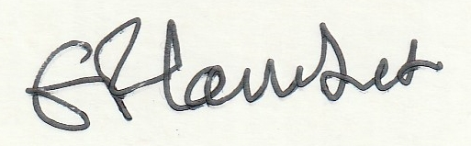
Frances Lambert Clerk of the Council

AGENDA – A.G.M.

Apologies for absence & to disclose personal and pecuniary interests in items of business listed below.

- To elect Chairman.

- To elect Vice-Chairman.

- To receive the Chairman’s Report for the year from 1/4/2018 to 31/3/2019.

- To approve the Accounts for the 2018/19 financial year.

- To confirm bank signatories.

- To consider Standing Orders & Financial Regulations.

- To consider the annual Risk Assessment.

- Appointment Of Officers.

- Appointment of an Internal Auditor for 2018/2019.

- Any Other Business.

AGENDA – MAY COUNCIL MEETING Monday 6th of May 2019
To the Chairman and Councillors of the Grosmont Fawr Community Council

You are summoned to attend the next meeting of the Grosmont Fawr Community Council, which will be held at the GROSMONT TOWN HALL, on MONDAY 13th of MAY at 8pm. The business to be transacted is as set out in the agenda below.
Frances Lambert - Clerk of the Council and Responsible Financial Officer

- To accept apologies for absence:

- To disclose personal and pecuniary interests in items of business listed below:

- Public Forum - (The meeting will be suspended to permit the Public Forum – 10 minutes only and each participant limited to 2 minutes. The meeting will then be re-opened.)

- To consider matters relating to the Rural Futures Project:

- To approve as a correct record the Minutes of previous meetings held – 11th MARCH 2019.

- To consider matters arising from the minutes:

- To receive items of correspondence:

- To consider matters relating to Highways / Rural Roads:

- To consider matters relating to planning – as listed below:
DM/2019/00492-Llanvetherine Court Farm, Llanvetherine, Abergavenny, Monmouthshire. NP7 8NL.
Fast track full planning permission.
Barn to have change of use from agricultural to use class D2 (with some A3).
Change of use of the adjacent covered structure from agricultural to mixed use, agricultural and class D2.

- To consider matters relating to Grosmont Town Hall:

- To consider matters relating to Grosmont Events.

- To agree expenditure and other accounts matters including donation requests policy.

- To receive and consider any other business: (Items for noting only – matters requiring further consideration will be listed for a future council meeting).

Date of next council meeting MONDAY 15th JULY 2019 at 7:30pm.

