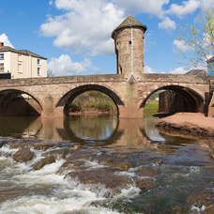

Monmouthshire NORTH MONTHLY UPDATE
June 2025

CRUCORNEY WARD

GROSMONT
COMMUNITY COUCIL

REPORTS RECEIVED:

04/06/25 – A report has been received of a two vehicle RTC. No injuries sustained

19/06/25 – A report has been received of a three vehicle RTC. No injuries sustained

*A465: There have been 8 reports this month ranging from RTCs to broken down vehicles.

Should you wish to report anything, then please do so through our 101 non-emergency number, our website, social media or 999 for an emergency.

ACTION PLANS:

- North Monmouthshire Burglaries
- 20mph Speed Limits

Monmouthshire NORTH Neighbourhood POLICING TEAM

@gwent.pnn.police.uk

Gwent Contact Page – To report incidents online.
Contact us | Gwent Police

