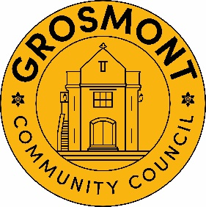
Grosmont Community Council
Cyngor Cymuned Grosmont

1st July 2025
To Members of the Council, you are hereby summoned to attend the
Monthly meeting of the Council
To be held on Tuesday 8th July 2025 at 7:30 pm at St Nicholas Church
Michaela Chaplin
Clerk to the Council

Members of the public and press are welcome to attend to observe proceedings. Documents referenced on the agenda may be obtained from the Clerk by emailing grosmontcouncil@hotmail.com or telephoning 07947346957
Members of the public may take the opportunity to ask questions, make representation and give information on any item on this agenda by either speaking to the Chair or Clerk prior to the meeting or raising a hand.
Agenda
- To accept apologies for absence
- To receive any declarations of interest
- To approve the minutes of the following meeting
  - Monthly Meeting dated 10th June 2025
- To consider matters arising from the minutes of the meetings held on Tuesday 10th June 2025
- To consider the progress of the work relating to the Town Hall project
  - Project Managers Report
  - To discuss Council representation at working parties
- To discuss Grosmont Online
  - New email addresses for Councillor
- To discuss land owned by Grosmont Community Council
- Matters Pertaining to Finance
  - Approve payment list
- To consider the approval of the following Policies: -
  - Training and Development Policy
  - Training Plan
  - Grant Awarding Policy
  - Health and Safety Policy

- To receive the Clerk’s Report on the Councillor Vacancy
- Planning Applications
  - DM/2025/00743 - Great Birches Grosmont Road Grosmont NP7 8HS - Retrospective application for an additional slurry lagoon to meet current environmental standards/regulations.
- To discuss Policing Matters within the Community
- To discuss the roads in and around Grosmont
- To discuss footpaths
- To receive items of correspondence
- Matters raised by members
- To confirm the date, time and venue of the next Monthly Council meeting -
Monthly Council Meeting Tuesday 9th September 2025 7:30 pm St Nicholas Church
- To consider passing a resolution that further to subsection (1) of Section 2 of the Public Bodies (Admission to Meetings) Act 1960, the public and press be excluded from the meeting during the following items by virtue of the nature of the business to be transacted.
- To discuss any matters above that are felt to be of a confidential nature
- To discuss any matters arising from the minutes of a confidential nature

