Grosmont Forever Report Findings and Next steps meeting
18.00-19.30 on 15.07.2025 @ The Nave
Attendees: 17 Grosmont residents

- Introduction and aims of meeting
PW welcomed everyone and provided a brief reminder of Energised Communities support and aims:
- 4 years remaining/ Lottery funded
- To address community priorities with a sustainability and energy focus
- Support community to identify and develop projects in line with prioritises from planning to project initiation
PW introduced the aims of the evening to familiarise, sense check and then build on what was said at the Grosmont Forever event and to think about some initial next steps. The evening consisted of a series of group activities based around key findings from the executive summary of the event report. PW explained that there were other important elements in the report such as the existing community assets which any action will need to consider and link to. Bilingual materials were provided throughout. All discussions were held in English, undertaken by 4 groups.

Activity 1: Sense checking community priorities
See “Bilingual Community priorities” file attached
PW explained that at the event attendees were asked to select the top 3 priorities from the preprepared list and the percentage of votes for each was discussed. Following discussion in groups it was agreed these were as expected and nothing has changed to affect these since the event. PW acknowledged this didn’t include other priorities raised by the community but that these would be explored as part of following activity discussions.

Activity 2: Sense checking and prioritising issues raised
See “bilingual issues” file attached
It was agreed that the issues listed were a true reflection of what was said at the event. Groups then prioritised each issue separately by assigning a number from 1-5 with 1 being high priority and 5 being low priority. It was noted that it was easy to reach consensus in groups about this and that there were a lot of 1’s -the highest priority issues.
Energy
3 of the 4 groups agreed the sub issues relating to energy were all the highest priority. One group thought this was low priority as they were unsure of the ability to change anything. It was noted that the issues under the energy heading were interconnected and would likely need to be addressed together. Witek informed attendees that CADW has a new Chief Listed Buildings officer who may have a pragmatic approach to changes that need to be made to buildings to make them fit for the future.
Transport
There was consensus that there was an urgent need to improve local transport options for all without access to their own vehicle including the elderly, disabled and younger people. 3 of the 4 groups listed this as a highest priority issue and the other group listing it as a 2 out of 5. Addressing the state of the roads and speeding was deemed a lower priority.
Food and Growing
The lack of availability of fresh produce and a growing space in the centre of the village was ranked a medium priority by groups
Waste and resource sharing
Issues around waste, wasteful consumption and sharing were deemed a medium priority across the groups, in part because of existing or planned initiatives.
Sustainability of community assets
There remains grave concern about the future of the village shop with 3 of the 4 groups listing this as a very high priority issue and the other group listing it as a 2 out of 5, putting it on a par with transport provision as a top priority.
Every group listed the lack of amenities for children as a 2, marking it as a high priority.
Conclusions about priority issues
It was agreed that all issues raised were important and should not be dismissed. However the top 3 priority areas were: energy, transport and sustainability of community assets.

Activity 3: Sense checking Ideas and Opportunities
See “Bilingual Ideas and Opportunities” file
Following a discussion in tables, it was agreed that the ideas listed were a true reflection of what was said at the event. PW noted that one idea that hadn’t been included was battery storage for the village. One group highlighted that any energy plan would need to include those with older inefficient electric heating systems in addition to oil.

Activity 4: Prioritization of ideas -Who could do it?
See “Activity 4- Who could do each idea results” file attached.
Groups were given sets of the ideas cut into strips and were asked to list each under the following headings to show who they thought could take action on each idea:
• Community
• Community with partners
• Other/ somebody else
• Not of Interest
There was no universal consensus across all groups. However, the following observations can be made.
Groups felt most of the ideas associated with “Transport and active tarvel”, “Food, growing and land use”, “Waste and resource sharing” and “Other community enhancements” could be done by the community or by the community working with partners.
There were more mixed responses for ideas sitting under “Energy”. These were largely recorded as either things the community could do in partnership or something for someone else to do.
There were only 2 ideas which were rejected as Not of Interest by more than one group. These were:
- Explore additional ways to make community buildings more energy efficient
- Solar phone-charging benches
It was noted that the hub project is already addressing the energy efficiency of the town hall.

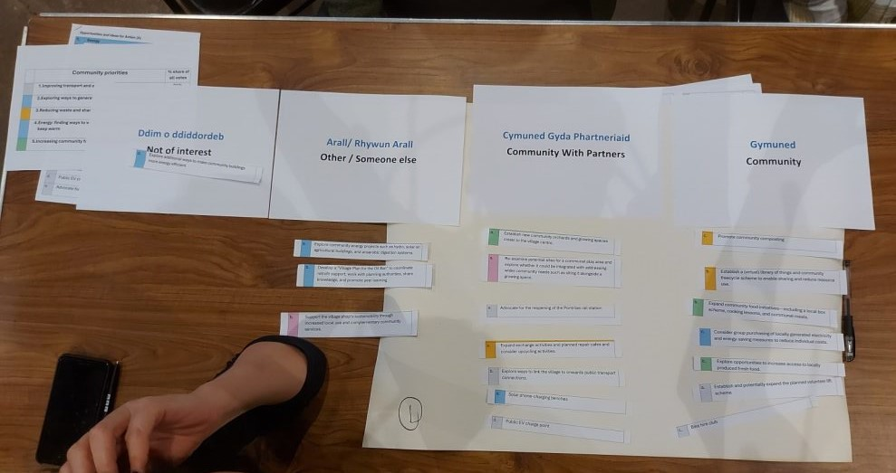
Activity 4-Results from one of the four discussion groups

Activity 5: Prioritisation -Your top 3 ideas
Attendees were asked to select their top 3 ideas both individually and as a group.
To help people decide, they were asked to consider:
- The ones you feel most passionate about?
- Which would have the biggest impact?
- Which would have the broadest support?
- Which could be relatively easily achieved / quick wins?
- Would it be best to do 3 things that address same issue or top 3 regardless of whether they sit under same theme?
Top ideas Results
There was a lot of consensus about the preferred ideas and notably the top ideas agreed as a group mirrored those chosen as individuals. Top ideas also correlated with the top issues agreed earlier in the meeting.
The top 6 ideas for both groups and individuals were:
Energy:
- Explore community energy projects such as hydro, solar on agricultural buildings, and anaerobic digestion systems.
- Develop a "Village Plan for the Oil Ban" to coordinate retrofit support, work with planning authorities, share knowledge, and promote peer learning.
- Consider group purchasing of locally generated electricity and energy-saving measures to reduce individual costs.
Transport and Active Travel:
- Explore ways to link the village to onwards public transport connections.
Other Community Enhancements :
- Re-examine potential sites for a communal play area and explore whether it could be integrated with addressing wider community needs such as siting it alongside a growing space.
- Support the village shop’s sustainability through increased local use and complementary community services.
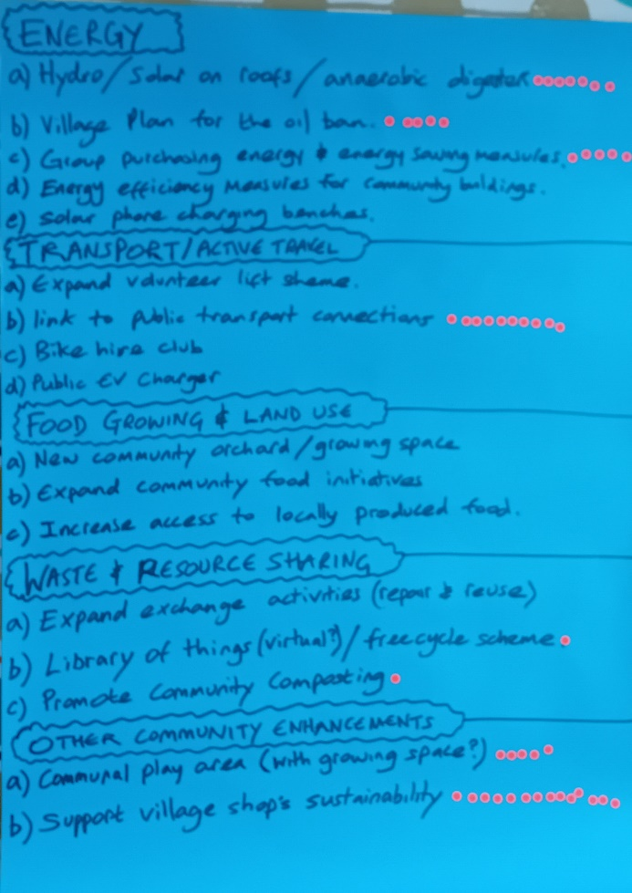
Activity 5: Dot voting of top ideas as individuals
Activity 6: Next steps
Due to time constraints next steps were briefly discussed as a group.
The following was agreed:
To meet again in September to explore top ideas further together as one group.
In the meantime, PW asked if there was anything:
- People could do individually/ as a group before the next meeting.
- They would like PW to do.
RB asked if there were any known resources for case studies/ support. PW suggested the following as a starter and also reminded attendees of the further reading list in the appendix of the event report. Now that top ideas have been agreed, further research can be undertaken to identify successful projects to emulate or learn from as well as appropriate support organisations. PW invited people to get in touch with him about any further specific requests of help.

Further Reading- Community energy:
Community Energy Wales: https://communityenergy.wales/
WG Energy Service: https://www.gov.wales/energy-service-public-sector-and-community-groups
Energy Local: https://energylocal.org.uk/
Community transport:
Community Transport Association (Wales): https://ctauk.org/cta-wales
Bridges Community Car scheme: https://bridgescentre.org.uk/car-scheme/
Rural Shops
Plunkett Foundation: https://plunkett.co.uk/

Date of next meeting:
September-To be confirmed

