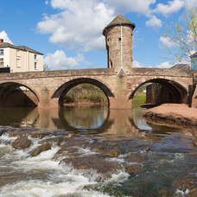

Monmouthshire NORTH MONTHLY UPDATE
July 2025

CRUCORNEY WARD

GROSMONT
COMMUNITY COUCIL

REPORTS RECEIVED:

08/07/25 – A report has been received of a suspicious vehicle on the B4347, this vehicle has driven on to a farm and drove off without stopping.

11/07/25 – A report has been received of a suspicious incident where a bag of dead crows has been left on the caller’s property in the Llanthony area.

19/07/25 – A report has been received of a possible abandoned vehicle in Grosmont. Officers attended, the vehicle was not causing any issues but was showing as SORN. DVLA have been informed.

*A465: There have been 9 reports this month ranging from RTCs to broken down vehicles.

Should you wish to report anything, then please do so through our 101 non-emergency number, our website, social media or 999 for an emergency.

ACTION PLANS:

- North Monmouthshire Burglaries
- 20mph Speed Limits

Monmouthshire NORTH Neighbourhood POLICING TEAM

@gwent.pnn.police.uk

Gwent Contact Page – To report incidents online.
Contact us | Gwent Police

