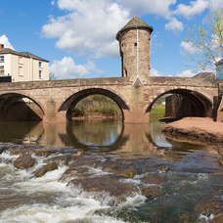

Monmouthshire NORTH MONTHLY UPDATE
August 2025

CRUCORNEY WARD

GROSMONT
COMMUNITY COUCIL

Crime Figures
These figures are for the CRUCORNEY ward area as a whole, which includes GROSMONT.

REPORTS RECEIVED:

07/08/25 – A report has been received from South Wales Fire and Rescue in relation to a deliberate fire in Cymyoy.

11/08/25 – A report has been received of theft from a vehicle where a wallet was stolen from the caller’s vehicle whilst it was parked in Fforest Coalpit.

11/08/25 – A report has been received of theft from a vehicle where a wallet, tent, and phone were stolen from the caller’s vehicle whilst it was parked in Fforest Coalpit.

*A465: There have been 9 reports this month ranging from RTCs to broken down vehicles.

Should you wish to report anything, then please do so through our 101 non-emergency number, our website, social media or 999 for an emergency.

ACTION PLANS:

- North Monmouthshire Burglaries
- 20mph Speed Limits

Monmouthshire NORTH Neighbourhood POLICING TEAM

@gwent.pnn.police.uk

Gwent Contact Page – To report incidents online.
Contact us | Gwent Police

