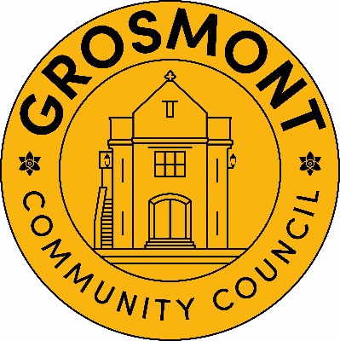
Training Plan 2025-2026
Date approved by Council 09/09/2025………………………….
Date of Planned Review May 2026……………………………
This training plan has been prepared in accordance with Section 67 of the 2021 Local Government and Elections (Wales) Act.
This training plan has been prepared based on the guidance issued by One Voice Wales and the Society of Local Councils. Councillor roles and employee roles have been assessed by reference to a set of core competencies for each role. This assessment has enabled the Council to prioritise its resources to enable all roles within the council to be supported by a well thought approach to its training and development needs. The commitment contained in this training plan will assist the council to enhance its approach to the delivery of high-quality services to its community.

The plan will be reviewed at least on an annual basis to ensure that it remains fit for purpose and accounts for the changing needs of councillors and employees as well as any turnover of councillors or employees.

This training plan should be viewed as a living document which can be updated from time to time, and it relates not only to the Council’s 7 Members but to any training needs which the Council’s staff may identify.
Following election or co-option, all Members of Councillors will be provided with information about a wide range of training courses with a view to ensuring that Members consider the skills that they need to perform their role as a Councillor or as a member of one of the Council’s Committees.
In particular, it is important to ensure that their level of knowledge is improved or maintained in relation to –
- Basic induction – particularly for new Members
- The Code of Conduct
- Financial Management and Governance.
The programme is outlined in the following table.
Course Title | Timeline | Source of Training | Target Audience | Attended | Cost
2025-2026
Code of Conduct | 2025 | OVW | All councillors |  | 2 Cllr spaces free  £42 each
The Council | 2025 |  | New Councillors
The Councillor | 2025 |  | New Councillors
Chairing skills | 2025 | OVW | The chair and vice chair
Local Government Finance | 2025/26 | OVW | 2 councillors |  | 2 Cllr spaces free
Understanding the law |  |  | 2 councillors |  | 2 Cllr spaces free
Council as an employer |  |  | Personnel Committee |  | 2 Cllr spaces free
Understanding Local Government Finance – Advanced |  |  | 2 councillors who have completed Local Government Finance |  | 2 Cllr spaces free
Finance and Governance Toolkit | 2025 | OVW | 2 councillors and the Clerk |  | 2 Cllr spaces free

