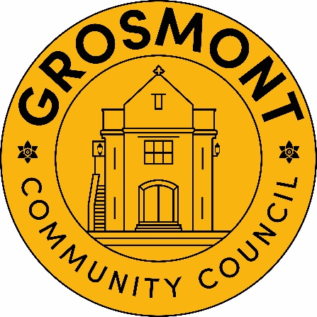
Cyngor Cymuned Grosmont
Michaela Chaplin
Clerc y Cyngor / Clerk to the Council
3 Heol Y Waun
Seven Sisters
Neath
SA10 9BL
Symudol / Mobile – 07947 346957
e-bost / e-mail – clerk@grosmont.wales

Publication of audited accounts for the year ended 31 March 2025

Regulation 15(5) of the Accounts and Audit (Wales) Regulations 2014 (as amended) requires that by 30 September 2025, Grosmont Community Council publish its accounting statements for the year ended 31 March 2025 together with any certificate, opinion, or report issued, given or made by the Auditor General.
The accounting statements, in the form of an annual return, have been published on the Council’s website. However, the Auditor General has not yet issued his audit opinion and report and therefore the accounts are published before the conclusion of the audit. The annual return will be published along with the Auditor General’s report and opinion when the audit is completed.

